8051 (AT89C51) PWM code + Proteus simulation
This post provides the PWM^{[1]} code ( using c language ) for 8051 micro-controller ( e-g for AT89C51 or AT89C52 etc ). There are many uses for PWM signals, e-g you can control dc motor speed using PWM. Timer0 is used here to generate the PWM. You can change the duty cycle in the code by changing the variable named 'PWM'. The PWM frequency can also be changed.
The code and Proteus simulation is given in the 'Downloads' section at the bottom of this page. It is assumed that you know how to configure timer0 in 8051 micro-controller. If you don't, then please read this post first.
The result of the Proteus simulation is shown below.
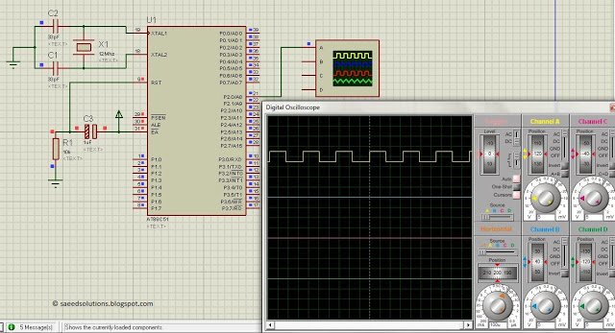
Figure 1. 8051 PWM circuit
In the above figure, PWM output is shown. Here, duty cycle is set to 50% and PWM frequency is set to about 3.3kHz.

Code
The code for the main function is shown below.
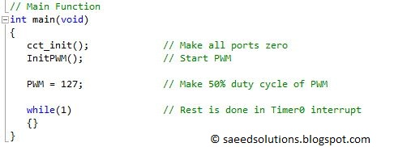
Figure 2. 8051 main function for PWM
In the main function, after initializing the PWM, a value of 127 is assigned to the PWM variable. You can assign a value of 0 (i-e 0% duty cycle) to 255 (i-e 100% duty cycle) to the PWM variable. That is why, PWM equal to 127 means 50% duty cycle. This can be verified from figure 1 ( In figure 1, we can see that the duty cycle of the output signal is 50% ).
The code required to generate PWM is shown below.
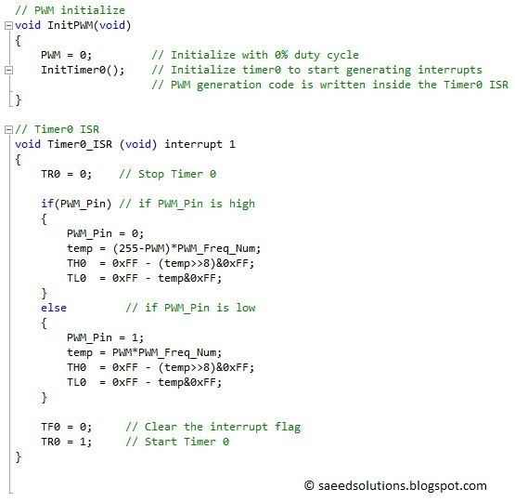
Figure 3. PWM code for 8051
In the InitPWM() function, timer0 is initialized in 16bit mode. Rest of the work is done in the timer0 ISR function, which is also shown in the above figure. Whenever timer0 ISR function is called, then timer0 is stopped at that time with TR0 = 0; statement. After that, depending upon the state of PWM variable and PWM pin (i-e if it is high or low), a suitable value is loaded in timer0 registers.
For example, if duty cycle is set to 25% and PWM pin is in low state, then this code will make PWM pin high and load a time of 25% in the timer0 registers. So, timer0 ISR function will be called again after 25% time, and then it will make PWM pin low and load a time of 75% in the timer0 registers. This cycle continuous forever. After loading new value in the timer0 registers and clearing the interrupt flag bit, timer0 starts again with the statement TR0 = 1;.
You can change the PWM frequency by changing the variable named PWM_Freq_Num. This is shown below in the figure.
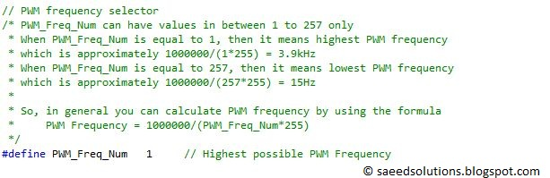
Figure 4. PWM frequency selection
You can select PWM frequency by the formula,
PWM Frequency = 1000000/(PWM_Freq_Num*255)
So, if you set PWM_Freq_Num equal to 1 (as shown above in the code), then PWM frequency will be about 3.9kHz (Actually it is lower in reality, because 8051 takes some time to execute the timer0 ISR code^{[2]}). Also, PWM_Freq_Num can have a value in between 1 to 257 only. This means that, PWM frequency can be changed from 15Hz (lowest) to 3.9kHz(Highest) when 12MHz crystal is being used with 8051 micro-controller.
As an example, You can use this PWM code to control dc motor with 8051 controller. You will need some sort of dc motor driver circuitry in between 8051 controller and the dc motor. Other than that, using this simple PWM controlling code, you can control dc motor speed with 8051 controller easily.
Notes and References
^{[1]} Pulse Width Modulation.
^{[2]} In ideal situation timer0 ISR function should be executed in 0 seconds to make 100% accurate PWM output. But in reality it is not possible and it takes at least about 40usec when 12MHz crystal is attached with 8051. You can however, change the value of crystal attached with 8051 from 12MHz to 24 MHz in order to reduce this slight PWM error. You can also generate PWM of up to 7.8kHz with 24MHz crystal.

